1. **FormUtama**A. Screenshot

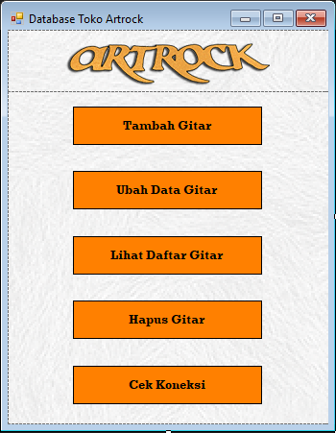

B. Source Code

|  |  |
| --- | --- |
| 1  2  3  4  5  6  7  8  9  10  11  12  13  14  15  16  17  18  19  20  21  22  23  24  25  26  27  28  29  30  31  32  33  34  35  36  37  38  39  40  41  42  43  44  45  46  47  48  49  50  51  52  53  54  55  56 | using System;  using System.Collections.Generic;  using System.ComponentModel;  using System.Data;  using System.Drawing;  using System.Linq;  using System.Text;  using System.Threading.Tasks;  using System.Windows.Forms;  using MySql.Data.MySqlClient;  namespace ArtRock  {  public partial class FormUtama : Form  {  public MySqlConnection connect;  public FormUtama()  {  InitializeComponent();  string connectionInfo = "datasource=localhost; port=3306; username=root; password=; database=artrockdb;SslMode=none";  connect = new MySqlConnection(connectionInfo);  }  private void btTambah_Click(object sender, EventArgs e)  {  FormTambah ftambah = new FormTambah();  ftambah.ShowDialog();  }  private void btUbahDataGitar_Click(object sender, EventArgs e)  {  FormUpdateAwal fupdatea = new FormUpdateAwal();  fupdatea.ShowDialog();  }  private void btLihatDataGitar_Click(object sender, EventArgs e)  {  FormTampil ftampil = new FormTampil();  ftampil.ShowDialog();  }  private void btHapusGitar_Click(object sender, EventArgs e)  {  FormHapus fHapus = new FormHapus();  fHapus.ShowDialog();  }  private void btCekKoneksi_Click(object sender, EventArgs e)  {  try  {  connect.Open();  MessageBox.Show("connected");  connect.Close();  }  catch (Exception ex)  {  MessageBox.Show(ex.Message);  }  }  }  } |

C. Penjelasan

1. **FormUpdateAwal**

A. Screenshot

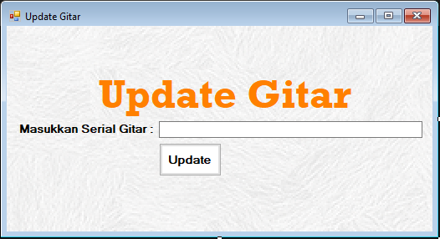

B. Source Code

|  |  |
| --- | --- |
| 1  2  3  4  5  6  7  8  9  10  11  12  13  14  15  16  17  18  19  20  21  22  23  24  25  26  27  28  29  30  31  32  33  34  35  36  37  38  3940  41  42  43  44  45  46  47  48 | using System;  using System.Collections.Generic;  using System.ComponentModel;  using System.Data;  using System.Drawing;  using System.Linq;  using System.Text;  using System.Threading.Tasks;  using System.Windows.Forms;  using MySql.Data.MySqlClient;  namespace ArtRock  {  public partial class FormUpdateAwal : Form  {  public FormUpdateAwal()  {  InitializeComponent();  }  private void btHapus_Click(object sender, EventArgs e)  {  try  {  string MyConnection3 = "datasource=localhost; port=3306; username=root; password=; database=artrockdb;SslMode=none";  string Query = "select*from gitar where Serial='" + this.textBox1.Text + "';";  MySqlConnection MyConn3 = new MySqlConnection(MyConnection3);  MySqlCommand MyCommand3 = new MySqlCommand(Query, MyConn3);  MySqlDataReader MyReader3;  MyConn3.Open();  MyReader3 = MyCommand3.ExecuteReader();  StringBuilder sb = new StringBuilder();  if(MyReader3.Read())  {  FormUpdate fupdate = new FormUpdate();  fupdate.ShowDialog();  }  else  {  MessageBox.Show("Gitar tidak ditemukan ! ");  }  MyConn3.Close();  }  catch (Exception ex)  {  MessageBox.Show(ex.Message);  }  }  }  } |

C. Penjelasan

1. **FormUpdate**
2. Screenshot

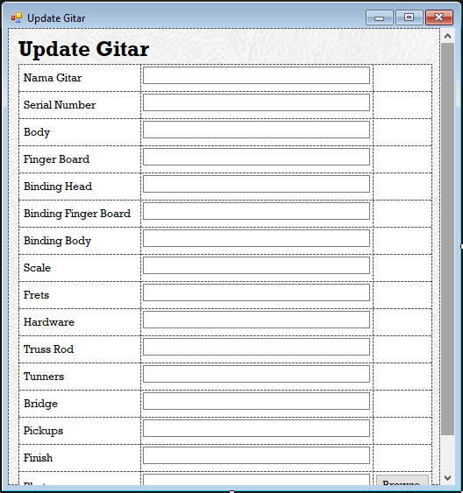

B. Source Code

|  |  |
| --- | --- |
| 1  2  3  4  5  6  7  8  9  10  11  12  13  14  15  16  17  18  19  20  21  22  23  24  25  26  27  28  29  30  31  32  33  34  35  36  37  38  39  40  41  42  43  44  45  46  47  48  49  50  51  52  53  54  55  56  57  58  59  60  61  62  63  64  65  66  67  68  69  70  71  72  73  74  75  76  77  78  79  80  81  82  83  84  85  86  87  88  89  90  91  92  93  94  95  96  97  98  99  100  101  102  103  104  105  106  107  108  109  110  111  112  113  114  115  116  117  118  119  120  121  122  123  124  125  126  127  128  129  130  131  132  133  134  135  136  137  138  139  140  141  142  143  144  145  146  147  148  149  150  151  152  153  154  155  156  157  158  159  160  161  162  163  164  165  166  167  168  169  170  171  172  173  174  175  176  177  178  179  180  181  182  183  184  185  186  187  188  189  190  191  192  193  194  195  196  197  198  199  200  201  202  203  204  205  206  207  208  209  210  211  212  213  214  215  216  217  218  219  220  221  222  223  224  225  226  227  228  229  230  231  232  233  234  235  236  237  238  239  240  241  242  243  244  245  246  247  248  249  250  251  252  253  254  255  256  257  258  259  260  261  162  263  264  265  266  267  268  269  270  271  272  273  274  275  276  277  278  279  280  281  282  283  284  285  286  287  288  289  290  291  292  293  294  295  296  297  298  299  300  301  302  303  304  305  306  307  308  309  400  401  402403404  405  406  407  408  409  500  501  502  503  504  505  506  507  508  509  510  511  512  513  514  515  516  517  518  519  520  521  522  523  524  525  527  528  529  530  531  532  533  534  535  536  537  538  539  540  541  542  543  544  545  546  547  548  549  550  551  552  553  554  555  556  557  558  559  560  561  562  563  564  565  566  567  568  569  570  571  572  573  574  575  576 | using System;  using System.Collections.Generic;  using System.ComponentModel;  using System.Data;  using System.Drawing;  using System.Linq;  using System.Text;  using System.Threading.Tasks;  using System.Windows.Forms;  using MySql.Data.MySqlClient;  using MetroFramework.Forms;  using System.IO;  using System.Threading;  namespace ArtRock  {  public partial class FormUtama : MetroForm  {  public MySqlConnection connect;  Thread th;  public FormUtama()  {  InitializeComponent();  string MyConnection2 = "datasource=localhost; port=3306; username=root; password=; database=artrockdb;SslMode=none";  connect = new MySqlConnection(MyConnection2);  string constring = "datasource=localhost; port=3306; username=root; password=; database=artrockdb;SslMode=none";  MySqlConnection conDataBase = new MySqlConnection(constring);  MySqlCommand sqlcom = new MySqlCommand("SELECT * FROM artrockdb.gitar", conDataBase);  try  {  MySqlDataAdapter sda = new MySqlDataAdapter();  sda.SelectCommand = sqlcom;  DataTable dta = new DataTable();  metroGrid1.AllowUserToAddRows = false;  sda.Fill(dta);  BindingSource bsource = new BindingSource();  bsource.DataSource = dta;  metroGrid1.DataSource = bsource;  sda.Update(dta);  metroGrid1.DataSource = dta;  DataGridViewImageColumn imageColumn = new DataGridViewImageColumn();  imageColumn = (DataGridViewImageColumn)metroGrid1.Columns[15];  imageColumn.ImageLayout = DataGridViewImageCellLayout.Zoom;  sda.Dispose();  }  catch (Exception ex)  {  MessageBox.Show(ex.Message);  }  }  public void lihatdata()  {  string connectionInfo = "datasource=localhost; port=3306; username=root; password=; database=artrockdb;SslMode=none";  connect = new MySqlConnection(connectionInfo);  string constring = "datasource=localhost; port=3306; username=root; password=; database=artrockdb;SslMode=none";  MySqlConnection conDataBase = new MySqlConnection(constring);  MySqlCommand sqlcom = new MySqlCommand("SELECT * FROM artrockdb.gitar", conDataBase);  try  {  MySqlDataAdapter sda = new MySqlDataAdapter();  sda.SelectCommand = sqlcom;  DataTable dta = new DataTable();  metroGrid1.AllowUserToAddRows = false;  sda.Fill(dta);  BindingSource bsource = new BindingSource();  bsource.DataSource = dta;  metroGrid1.DataSource = bsource;  sda.Update(dta);  metroGrid1.DataSource = dta;  DataGridViewImageColumn imageColumn = new DataGridViewImageColumn();  imageColumn = (DataGridViewImageColumn)metroGrid1.Columns[15];  imageColumn.ImageLayout = DataGridViewImageCellLayout.Zoom;  sda.Dispose();  }  catch (Exception ex)  {  MessageBox.Show(ex.Message);  }  }  private void btCekKoneksi_Click(object sender, EventArgs e)  {  try  {  connect.Open();  MessageBox.Show("connected");  connect.Close();  }  catch (Exception ex)  {  MessageBox.Show(ex.Message);  }  }  private void btSave_Click(object sender, EventArgs e)  {  if (textBox1.Text != "" && textBox2.Text != "" && textBox3.Text != "" &&  textBox4.Text != "" && textBox5.Text != "" && textBox6.Text != "" &&  textBox7.Text != "" && textBox8.Text != "" && textBox9.Text != "" &&  textBox10.Text != "" && textBox11.Text != "" && textBox12.Text != "" &&  textBox13.Text != "" && textBox14.Text != "" && textBox15.Text != "" /*&&  textBox16.Text != ""*/)  {  try  {  MemoryStream ms = new MemoryStream();  pictureBox1.Image.Save(ms, pictureBox1.Image.RawFormat);  byte[] img = ms.ToArray();  string MyConnection2 = "datasource=localhost; port=3306; username=root; password=; database=artrockdb;SslMode=none";  string queri = "insert into artrockdb.gitar(Nama_Gitar,Serial,Body,Finger_Board,Binding_Head,Binding_Finger_Board,Binding_Body,Scale,Frets,Hardware,Truss_Rod,Tunners,Bridge,Pickups,Finish,Photo)VALUES(@Nama_Gitar,@Serial,@Body,@Finger_Board,@Binding_Head,@Binding_Finger_Board,@Binding_Body,@Scale,@Frets,@Hardware,@Truss_Rod,@Tunners,@Bridge,@Pickups,@Finish,@Photo)";  MySqlConnection MyConn2 = new MySqlConnection(MyConnection2);  MyConn2.Open();  MySqlCommand MyCommand2 = new MySqlCommand(queri, MyConn2);  MyCommand2.Parameters.Add("@Nama_Gitar", MySqlDbType.VarChar, 255);  MyCommand2.Parameters.Add("@Serial", MySqlDbType.VarChar, 255);  MyCommand2.Parameters.Add("@Body", MySqlDbType.VarChar, 255);  MyCommand2.Parameters.Add("@Finger_Board", MySqlDbType.VarChar, 255);  MyCommand2.Parameters.Add("@Binding_Head", MySqlDbType.VarChar, 255);  MyCommand2.Parameters.Add("@Binding_Finger_Board", MySqlDbType.VarChar, 255);  MyCommand2.Parameters.Add("@Binding_Body", MySqlDbType.VarChar, 255);  MyCommand2.Parameters.Add("@Scale", MySqlDbType.VarChar, 255);  MyCommand2.Parameters.Add("@Frets", MySqlDbType.VarChar, 255);  MyCommand2.Parameters.Add("@Hardware", MySqlDbType.VarChar, 255);  MyCommand2.Parameters.Add("@Truss_Rod", MySqlDbType.VarChar, 255);  MyCommand2.Parameters.Add("@Tunners", MySqlDbType.VarChar, 255);  MyCommand2.Parameters.Add("@Bridge", MySqlDbType.VarChar, 255);  MyCommand2.Parameters.Add("@Pickups", MySqlDbType.VarChar, 255);  MyCommand2.Parameters.Add("@Finish", MySqlDbType.VarChar, 255);  MyCommand2.Parameters.Add("@Photo", MySqlDbType.Blob);  MyCommand2.Parameters["@Nama_Gitar"].Value = this.textBox1.Text;  MyCommand2.Parameters["@Serial"].Value = this.textBox2.Text;  MyCommand2.Parameters["@Body"].Value = this.textBox3.Text;  MyCommand2.Parameters["@Finger_Board"].Value = this.textBox4.Text;  MyCommand2.Parameters["@Binding_Head"].Value = this.textBox5.Text;  MyCommand2.Parameters["@Binding_Finger_Board"].Value = this.textBox6.Text;  MyCommand2.Parameters["@Binding_Body"].Value = this.textBox7.Text;  MyCommand2.Parameters["@Scale"].Value = this.textBox8.Text;  MyCommand2.Parameters["@Frets"].Value = this.textBox9.Text;  MyCommand2.Parameters["@Hardware"].Value = this.textBox10.Text;  MyCommand2.Parameters["@Truss_Rod"].Value = this.textBox11.Text;  MyCommand2.Parameters["@Tunners"].Value = this.textBox12.Text;  MyCommand2.Parameters["@Bridge"].Value = this.textBox13.Text;  MyCommand2.Parameters["@Pickups"].Value = this.textBox14.Text;  MyCommand2.Parameters["@Finish"].Value = this.textBox15.Text;  MyCommand2.Parameters["@Photo"].Value = img;  if (MyCommand2.ExecuteNonQuery() == 1)  {  MessageBox.Show("Gitar Berhasil Ditambahkan");  }  MyConn2.Close();  textBox1.Clear();  textBox2.Clear();  textBox3.Clear();  textBox4.Clear();  textBox5.Clear();  textBox6.Clear();  textBox7.Clear();  textBox8.Clear();  textBox9.Clear();  textBox10.Clear();  textBox11.Clear();  textBox12.Clear();  textBox13.Clear();  textBox14.Clear();  textBox15.Clear();  textBox16.Clear();  }  catch (Exception ex)  {  MessageBox.Show(ex.Message);  }  }  else  {  MessageBox.Show("Semua kolom harus terisi");  }  }  private void btCariGambar_Click(object sender, EventArgs e)  {  OpenFileDialog opf = new OpenFileDialog();  opf.Filter = "Choose image(*.jpg;*.png;*.gif|*.jpg;*.png;*.gif";  if (opf.ShowDialog() == DialogResult.OK)  {  pictureBox1.Image = Image.FromFile(opf.FileName);  textBox16.Text = opf.FileName;  }  }  private void btHapus_Click(object sender, EventArgs e)  {  if (MessageBox.Show("Hapus Data Gitar Ini?", "Hapus Gitar", MessageBoxButtons.YesNo, MessageBoxIcon.Question) == DialogResult.Yes)  {  try  {  string MyConnection2 = "datasource=localhost; port=3306; username=root; password=; database=artrockdb;SslMode=none";  string Query = "delete from gitar where Serial='" + this.textBox18.Text + "';";  MySqlConnection MyConn2 = new MySqlConnection(MyConnection2);  MySqlCommand MyCommand2 = new MySqlCommand(Query, MyConn2);  MySqlDataReader MyReader2;  MyConn2.Open();  MyReader2 = MyCommand2.ExecuteReader();  MessageBox.Show("Gitar Dihapus");  while (MyReader2.Read())  {  }  MyConn2.Close();  textBox18.Clear();  }  catch (Exception ex)  {  MessageBox.Show(ex.Message);  }  }  else  {  MessageBox.Show("Gitar Tidak Dihapus", "Hapus Gitar", MessageBoxButtons.OK, MessageBoxIcon.Information);  }  }  private void metroLink1_Click(object sender, EventArgs e)  {  try  {  connect.Open();  MessageBox.Show("Berhasil Terkoneksi!");  connect.Close();  }  catch (Exception ex)  {  MessageBox.Show(ex.Message);  }  }  private void metroLink2_Click(object sender, EventArgs e)  {  lihatdata();  }  private void btCari_Click(object sender, EventArgs e)  {  {  try  {  string MyConnection3 = "datasource=localhost; port=3306; username=root; password=; database=artrockdb;SslMode=none";  string Query = "select* from gitar where Serial='" + this.tbCari.Text + "';";  MySqlConnection MyConn3 = new MySqlConnection(MyConnection3);  MySqlCommand MyCommand3 = new MySqlCommand(Query, MyConn3);  MySqlDataReader MyReader3;  MyConn3.Open();  MyReader3 = MyCommand3.ExecuteReader();  StringBuilder sb = new StringBuilder();  if (MyReader3.Read())  {  FormUpdate fupdate = new FormUpdate();  fupdate.ShowDialog();  }  else  {  MessageBox.Show("Gitar tidak ditemukan!");  }  MyConn3.Close();  tbCari.Clear();  }  catch (Exception ex)  {  MessageBox.Show(ex.Message);  }  }  }  private void btClear_Click(object sender, EventArgs e)  {  textBox1.Clear();  textBox2.Clear();  textBox3.Clear();  textBox4.Clear();  textBox5.Clear();  textBox6.Clear();  textBox7.Clear();  textBox8.Clear();  textBox9.Clear();  textBox10.Clear();  textBox11.Clear();  textBox12.Clear();  textBox13.Clear();  textBox14.Clear();  textBox15.Clear();  textBox16.Clear();  }  private void metroLink3_Click(object sender, EventArgs e)  {  this.Close();  th = new Thread(bukaformbaru);  th.SetApartmentState(ApartmentState.STA);  th.Start();  }  private void bukaformbaru(object obj)  {  Application.Run(new login());  }  }  } |

|  |  |
| --- | --- |
| 1  2  3  4  5  6  7  8  9  10  11  12  13  14  15  16  17  18  19  20  21  22  23  24  25  26  27  28  29  30  31  32  33  34  35  36  37  38  39  40  41  42  43  44  45  46  47  48  49  50  51  52  53  54  55  56  57  58  59  60  61  62  63  64  65  66  67  68  69  70  71  72  73  74  75  76  77  78  79  80  81  82  83  84  85  86  87  88  89 | using System;  using System.Collections.Generic;  using System.ComponentModel;  using System.Data;  using System.Drawing;  using System.Linq;  using System.Text;  using System.Threading.Tasks;  using System.Windows.Forms;  using MySql.Data.MySqlClient;  namespace ArtRock  {  public partial class FormUpdate : Form  {  public MySqlConnection MyConn1;  MySqlDataReader myReader;  public FormUpdate()  {  InitializeComponent();  string MyConnection2 = "datasource=localhost; port=3306; username=root; password=; database=artrockdb;SslMode=none";  MyConn1 = new MySqlConnection(MyConnection2);  try  {  string query = "select*from gitar";  MyConn1.Open();  MySqlCommand myCommand = new MySqlCommand(query, MyConn1);  myReader = myCommand.ExecuteReader();  while (myReader.Read())  {  textBox1.Text = myReader[0].ToString();  textBox2.Text = myReader[1].ToString();  textBox3.Text = myReader[2].ToString();  textBox4.Text = myReader[3].ToString();  textBox5.Text = myReader[4].ToString();  textBox6.Text = myReader[5].ToString();  textBox7.Text = myReader[6].ToString();  textBox8.Text = myReader[7].ToString();  textBox9.Text = myReader[8].ToString();  textBox10.Text = myReader[9].ToString();  textBox11.Text = myReader[10].ToString();  textBox12.Text = myReader[11].ToString();  textBox13.Text = myReader[12].ToString();  textBox14.Text = myReader[13].ToString();  textBox15.Text = myReader[14].ToString();  textBox16.Text = myReader[15].ToString();  }  myReader.Close();  MyConn1.Close();  }  catch (Exception ex)  {  MessageBox.Show(ex.Message);  }  }  private void btUpdate_Click(object sender, EventArgs e)  {  try  {  MyConn1.Open();  string Query = "update gitar set Nama_Gitar='" + this.textBox1.Text + "',"  + "Serial='" + this.textBox2.Text + "',"  + "Body='" + this.textBox3.Text + "',"  + "Finger_Board='" + this.textBox4.Text + "',"  + "Binding_Head='" + this.textBox5.Text + "',"  + "Binding_Finger_Board='" + this.textBox6.Text + "',"  + "Binding_Body='" + this.textBox7.Text + "',"  + "Scale='" + this.textBox8.Text + "',"  + "Frets='" + this.textBox9.Text + "',"  + "Hardware='" + this.textBox10.Text + "',"  + "Truss_Rod='" + this.textBox11.Text + "',"  + "Tunners='" + this.textBox12.Text + "',"  + "Bridge='" + this.textBox13.Text + "',"  + "Pickups='" + this.textBox14.Text + "',"  + "Finish='" + this.textBox15.Text + "',"  + "Photo='" + this.textBox16.Text + "'"  + " where Serial='" + this.textBox2.Text + "';";  MySqlCommand MyCommand2 = new MySqlCommand(Query, MyConn1);  myReader = MyCommand2.ExecuteReader();  MessageBox.Show("Data Updated");  myReader.Close();  MyConn1.Close();  }  catch(Exception ex)  {  MessageBox.Show(ex.Message);  }  }  }  } |

C. Penjelasan

1. **FormTampil**
2. Screenshot

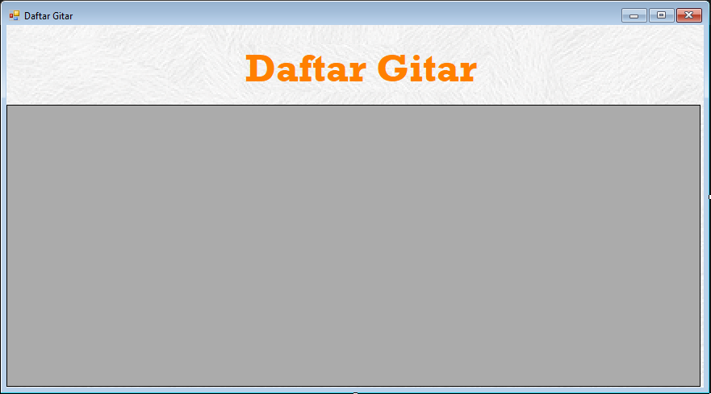

B. Source Code

|  |  |
| --- | --- |
| 1  2  3  4  5  6  7  8  9  10  11  12  13  14  15  16  17  18  19  20  21  22  23  24  25  26  27  28  29  30  31  32  33  34  3536  37  38  39  40  41  42  43  44  45  46  47  48 | using System;  using System.Collections.Generic;  using System.ComponentModel;  using System.Data;  using System.Drawing;  using System.Linq;  using System.Text;  using System.Threading.Tasks;  using System.Windows.Forms;  using MySql.Data.MySqlClient;  namespace ArtRock  {  public partial class FormTampil : Form  {  public MySqlConnection MyConn1;  MySqlDataReader myReader;  public FormTampil()  {  InitializeComponent();  string MyConnection2 = "datasource=localhost; port=3306; username=root; password=; database=artrockdb;SslMode=none";  MyConn1 = new MySqlConnection(MyConnection2);  string constring = "datasource=localhost; port=3306; username=root; password=; database=artrockdb;SslMode=none";  MySqlConnection conDataBase = new MySqlConnection(constring);  MySqlCommand sqlcom = new MySqlCommand("SELECT * FROM artrockdb.gitar", conDataBase);  try  {  MySqlDataAdapter sda = new MySqlDataAdapter();  sda.SelectCommand = sqlcom;  DataTable dta = new DataTable();  dataGridView1.AllowUserToAddRows = false;  sda.Fill(dta);  BindingSource bsource = new BindingSource();  bsource.DataSource = dta;  dataGridView1.DataSource = bsource;  sda.Update(dta);  dataGridView1.DataSource = dta;  DataGridViewImageColumn imageColumn = new DataGridViewImageColumn();  imageColumn = (DataGridViewImageColumn)dataGridView1.Columns[15];  imageColumn.ImageLayout = DataGridViewImageCellLayout.Stretch;  sda.Dispose();  }  catch (Exception ex)  {  MessageBox.Show(ex.Message);  }  }  }  } |

C. Penjelasan

1. **FormTambah**

A. Screenshot

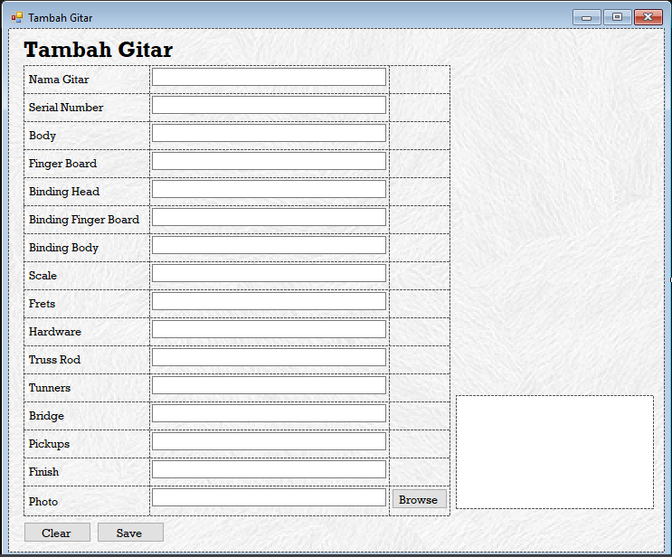

B. Source Code

|  |  |
| --- | --- |
| 1  2  3  4  5  6  7  8  9  10  11  12  13  14  15  16  17  18  19  20  21  22  23  24  25  26  27  28  29  30  31  32  33  34  35  36  37  38  39  40  41  42  43  44  45  46  47  48  49  50  51  52  53  54  55  56  57  58  59  60  61  62  63  64  65  66  67  68  69  70  71  72  73  74  75  76  77  78  79  80  81  82  83  84  85  86  87  88  89  90  91  92  93  94  95  96  97  98  99  100 | using System;  using System.Collections.Generic;  using System.ComponentModel;  using System.Data;  using System.Drawing;  using System.IO;  using System.Linq;  using System.Text;  using System.Threading.Tasks;  using System.Windows.Forms;  using MySql.Data.MySqlClient;  namespace ArtRock  {  public partial class FormTambah : Form  {  FormUtama fmain;  private FormUtama formUtama;  public FormTambah()  {  InitializeComponent();  }  private void btSave_Click(object sender, EventArgs e)  {  if (textBox1.Text != "" && textBox2.Text != "" && textBox3.Text != "" &&  textBox4.Text != "" && textBox5.Text != "" && textBox6.Text != "" &&  textBox7.Text != "" && textBox8.Text != "" && textBox9.Text != "" &&  textBox10.Text != "" && textBox11.Text != "" && textBox12.Text != "" &&  textBox13.Text != "" && textBox14.Text != "" && textBox15.Text != "" /*&&  textBox16.Text != ""*/)  {  try  {  MemoryStream ms = new MemoryStream();  pictureBox1.Image.Save(ms, pictureBox1.Image.RawFormat);  byte[] img = ms.ToArray();  string MyConnection2 = "datasource=localhost; port=3306; username=root; password=; database=artrockdb;SslMode=none";  string queri = "insert into artrockdb.gitar(Nama_Gitar,Serial,Body,Finger_Board,Binding_Head,Binding_Finger_Board,Binding_Body,Scale,Frets,Hardware,Truss_Rod,Tunners,Bridge,Pickups,Finish,Photo)VALUES(@Nama_Gitar,@Serial,@Body,@Finger_Board,@Binding_Head,@Binding_Finger_Board,@Binding_Body,@Scale,@Frets,@Hardware,@Truss_Rod,@Tunners,@Bridge,@Pickups,@Finish,@Photo)";  MySqlConnection MyConn2 = new MySqlConnection(MyConnection2);  MyConn2.Open();  MySqlCommand MyCommand2 = new MySqlCommand(queri, MyConn2);  MyCommand2.Parameters.Add("@Nama_Gitar", MySqlDbType.VarChar,255);  MyCommand2.Parameters.Add("@Serial", MySqlDbType.VarChar,255);  MyCommand2.Parameters.Add("@Body", MySqlDbType.VarChar, 255);  MyCommand2.Parameters.Add("@Finger_Board", MySqlDbType.VarChar, 255);  MyCommand2.Parameters.Add("@Binding_Head", MySqlDbType.VarChar, 255);  MyCommand2.Parameters.Add("@Binding_Finger_Board", MySqlDbType.VarChar, 255);  MyCommand2.Parameters.Add("@Binding_Body", MySqlDbType.VarChar, 255);  MyCommand2.Parameters.Add("@Scale", MySqlDbType.VarChar, 255);  MyCommand2.Parameters.Add("@Frets", MySqlDbType.VarChar, 255);  MyCommand2.Parameters.Add("@Hardware", MySqlDbType.VarChar, 255);  MyCommand2.Parameters.Add("@Truss_Rod", MySqlDbType.VarChar, 255);  MyCommand2.Parameters.Add("@Tunners", MySqlDbType.VarChar, 255);  MyCommand2.Parameters.Add("@Bridge", MySqlDbType.VarChar, 255);  MyCommand2.Parameters.Add("@Pickups", MySqlDbType.VarChar, 255);  MyCommand2.Parameters.Add("@Finish", MySqlDbType.VarChar, 255);  MyCommand2.Parameters.Add("@Photo", MySqlDbType.Blob);  MyCommand2.Parameters["@Nama_Gitar"].Value = this.textBox1.Text;  MyCommand2.Parameters["@Serial"].Value = this.textBox2.Text;  MyCommand2.Parameters["@Body"].Value = this.textBox3.Text;  MyCommand2.Parameters["@Finger_Board"].Value = this.textBox4.Text;  MyCommand2.Parameters["@Binding_Head"].Value = this.textBox5.Text;  MyCommand2.Parameters["@Binding_Finger_Board"].Value = this.textBox6.Text;  MyCommand2.Parameters["@Binding_Body"].Value = this.textBox7.Text;  MyCommand2.Parameters["@Scale"].Value = this.textBox8.Text;  MyCommand2.Parameters["@Frets"].Value = this.textBox9.Text;  MyCommand2.Parameters["@Hardware"].Value = this.textBox10.Text;  MyCommand2.Parameters["@Truss_Rod"].Value = this.textBox11.Text;  MyCommand2.Parameters["@Tunners"].Value = this.textBox12.Text;  MyCommand2.Parameters["@Bridge"].Value = this.textBox13.Text;  MyCommand2.Parameters["@Pickups"].Value = this.textBox14.Text;  MyCommand2.Parameters["@Finish"].Value = this.textBox15.Text;  MyCommand2.Parameters["@Photo"].Value = img;  if (MyCommand2.ExecuteNonQuery() == 1)  {  MessageBox.Show("Gitar Berhasil Ditambahkan");  }  MyConn2.Close();  }  catch (Exception ex)  {  MessageBox.Show(ex.Message);  }  }  else  {  MessageBox.Show("Semua kolom harus terisi");  }  }  private void btCariGambar_Click(object sender, EventArgs e)  {  OpenFileDialog opf = new OpenFileDialog();  opf.Filter = "Choose image(*.jpg;*.png;*.gif|*.jpg;*.png;*.gif";  if (opf.ShowDialog() == DialogResult.OK)  {  pictureBox1.Image = Image.FromFile(opf.FileName);  textBox16.Text = opf.FileName;  }  }  }  } |

C. Penjelasan

1. **FormHapus**
2. Screenshot

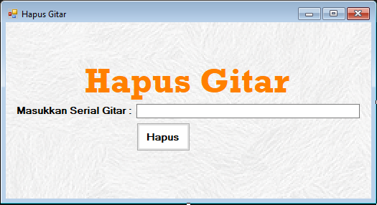

B. Source Code

|  |  |
| --- | --- |
| 1  2  3  4  5  6  7  8  9  10  11  12  13  14  15  16  17  18  19  20  21  22  23  24  25  26  27  28  29  30  31  32  33  34  35  36  37  38  39  40  41  42 | using System;  using System.Collections.Generic;  using System.ComponentModel;  using System.Data;  using System.Drawing;  using System.Linq;  using System.Text;  using System.Threading.Tasks;  using System.Windows.Forms;  using MySql.Data.MySqlClient;  namespace ArtRock  {  public partial class FormHapus : Form  {  public FormHapus()  {  InitializeComponent();  }  private void btHapus_Click(object sender, EventArgs e)  {  try  {  string MyConnection2 = "datasource=localhost; port=3306; username=root; password=; database=artrockdb;SslMode=none";  string Query = "delete from gitar where Serial='" + this.textBox1.Text + "';";  MySqlConnection MyConn2 = new MySqlConnection(MyConnection2);  MySqlCommand MyCommand2 = new MySqlCommand(Query, MyConn2);  MySqlDataReader MyReader2;  MyConn2.Open();  MyReader2 = MyCommand2.ExecuteReader();  MessageBox.Show("Data Deleted");  while (MyReader2.Read())  {  }  MyConn2.Close();  }  catch (Exception ex)  {  MessageBox.Show(ex.Message);  }  }  }  } |

C. Penjelasan